Python and Oracle database communication
In order to communicate with oracle database, python program required libraries.
- cx_Oracle
- oracledb

These libraries are provided Oracle Corporation.

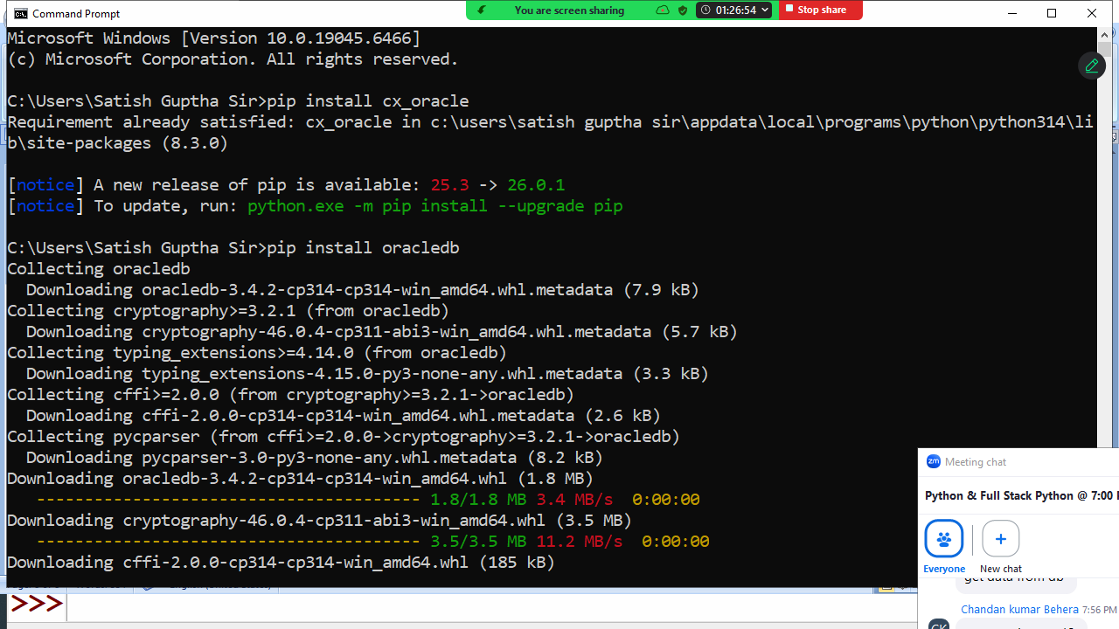

Before installing oracle libraries first install oracle database software.

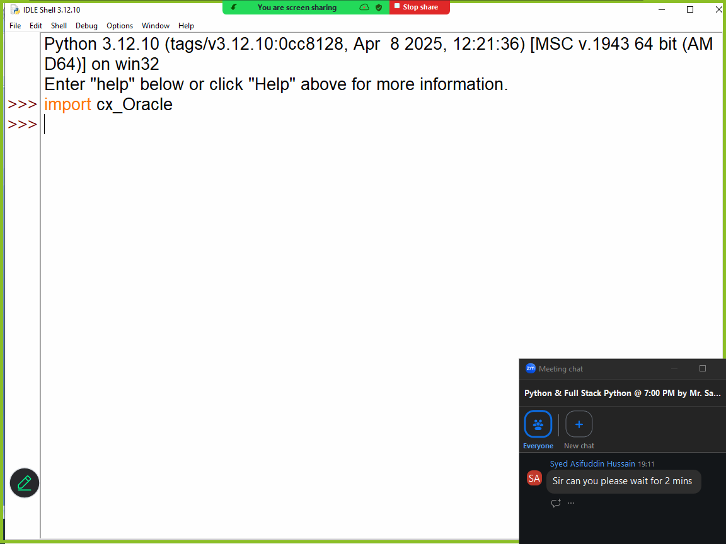

Example:
# Write a program to establish connection to oracle database

import cx_Oracle

cn=cx_Oracle.connect("system/tiger@localhost:1521/XE")
print("Connection Established")
cn.close()

# system --> username
# tiger --> password
# host --> localhost/ipaddress
#port : 1521
# databasename: XE

Output
Connection Established

Example:
# Write a program to create table within oracle database

import cx_Oracle

cn=cx_Oracle.connect("system/tiger@localhost:1521/XE")
c=cn.cursor()
SQL='''create table emp(empno number(5) primary key,
ename varchar2(20),
salary number(10,2))'''
c.execute(SQL)
print("Table Created")
cn.close()

Output
Table Created

Example:
# Write a program to insert data inside emp table

import cx_Oracle
cn=cx_Oracle.connect("system/tiger@localhost:1521/XE")
c=cn.cursor()
SQL="insert into emp values(:1,:2,:3)"
while True:
empno=int(input("EmployeeNo :"))
ename=input("EmployeeName :")
sal=float(input("EmployeeSalary:"))
c.execute(SQL,[empno,ename,sal])
cn.commit()
ans=input("Add another employee?")
if ans=="no":
break
cn.close()

Output
EmployeeNo :1
EmployeeName :naresh
EmployeeSalary:45000
Add another employee?yes
EmployeeNo :2
EmployeeName :suresh
EmployeeSalary:25000
Add another employee?yes
EmployeeNo :3
EmployeeName :kishore
EmployeeSalary:15000
Add another employee?yes
EmployeeNo :4
EmployeeName :kiran
EmployeeSalary:21000
Add another employee?no

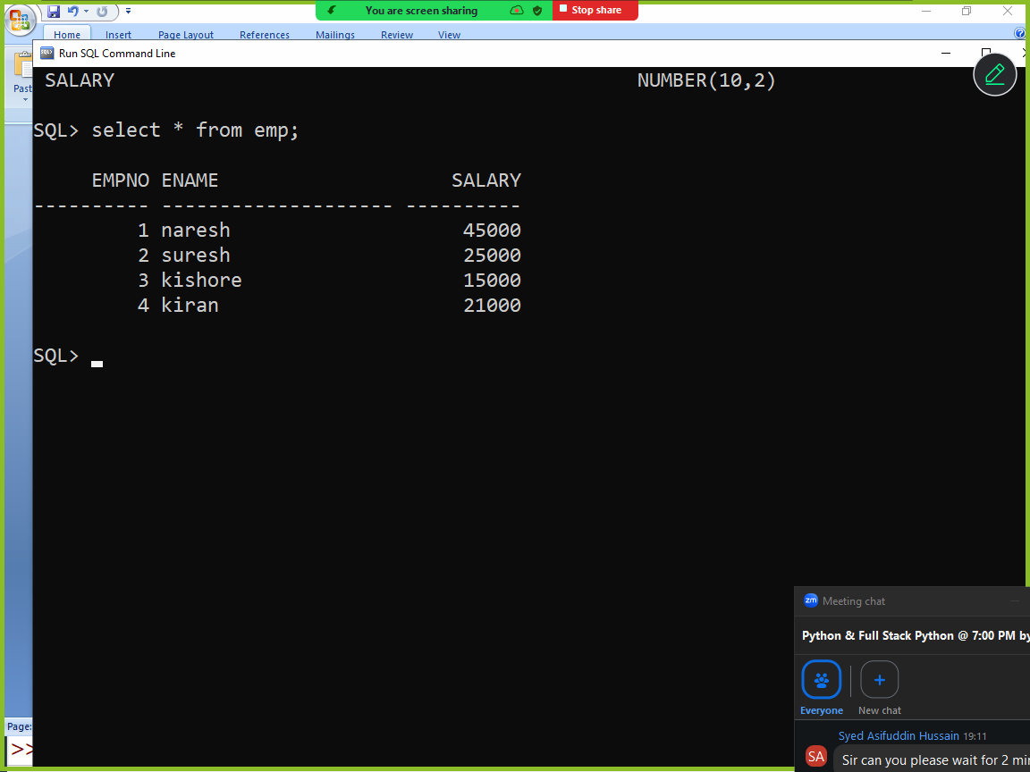

Example:
# Write a program to read data from emp table

import cx_Oracle
cn=cx_Oracle.connect("system/tiger@localhost:1521/XE")
c=cn.cursor()
SQL="SELECT * FROM EMP"
c.execute(SQL)
employees=c.fetchall()
for row in employees:
print(row)

cn.close()

Output
(1, 'naresh', 45000.0)
(2, 'suresh', 25000.0)
(3, 'kishore', 15000.0)
(4, 'kiran', 21000.0)

MongoDB database
Mongodb is NO SQL database
MongoDB is a document database. It stores data in a type of JSON format called BSON.
A record in MongoDB is a document, which is a data structure composed of key value pairs similar to the structure of JSON objects.

To work with mongodb,
- install mongodb software
- install pymongo (library)

install mongodb software
https://www.mongodb.com/try/download/community

install pymongo

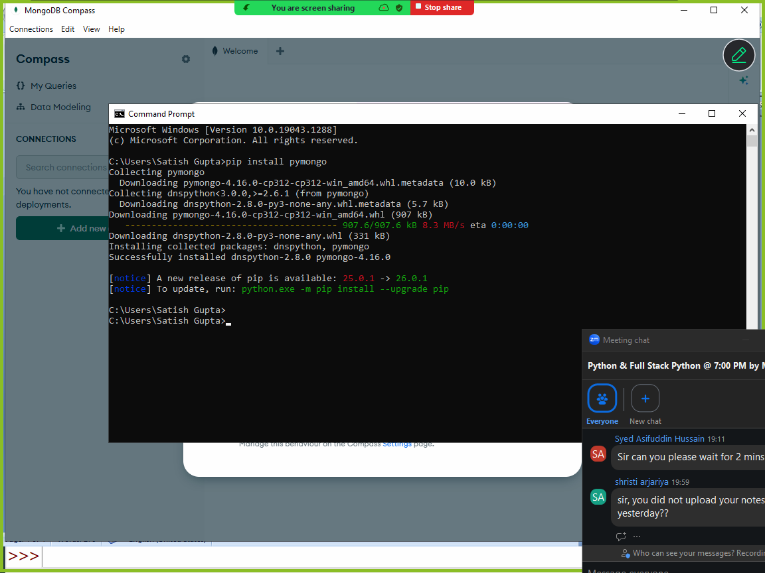

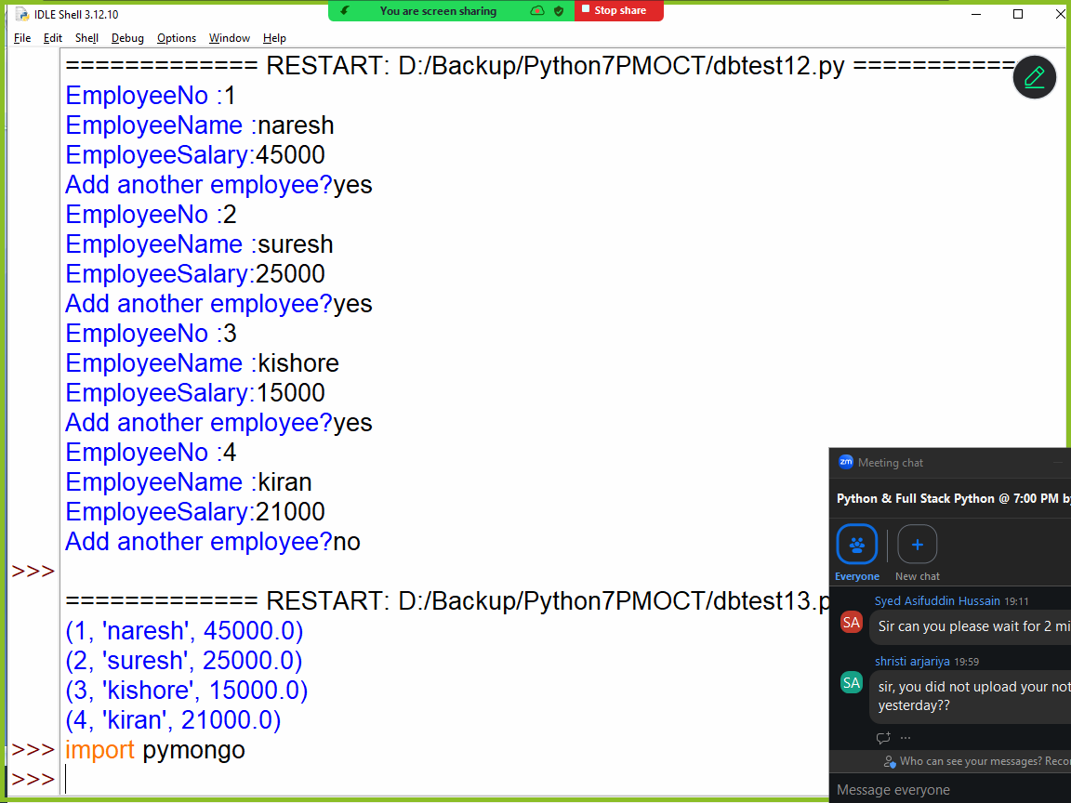

Example:
# Write a program to create database and collection (table) and insert data(document)

import pymongo
cn = pymongo.MongoClient("mongodb://localhost:27017/")
mydb = cn["database2"]
collection=mydb["student"]
collection.insert_one({'rollno':1,'name':'naresh','course':'python'})
collection.insert_one({'rollno':2,'name':'suresh','course':'java'})

Example:
# Write a program to insert multiple documents

import pymongo
cn = pymongo.MongoClient("mongodb://localhost:27017/")
mydb = cn["database2"]
collection=mydb["student"]
collection.insert_many([{'rollno':3,'name':'kiran','course':'c++'},
{'rollno':4,'name':'kishore','course':'c'}])
print("documents are inserted")

# Write a program to read data from mongodb collection(table)
import pymongo
cn = pymongo.MongoClient("mongodb://localhost:27017/")
mydb = cn["database2"]
collection=mydb["student"]
documents=collection.find()
print(documents)
for doc in documents:
print(doc['rollno'],doc['name'],doc['course'])

document=collection.find_one()
print(document)
document=collection.find_one({'rollno':2})
print(document)

Output
<pymongo.synchronous.cursor.Cursor object at 0x00000226FB379FA0>
1 naresh python
2 suresh java
3 kiran c++
4 kishore c
{'_id': ObjectId('698600fc60a7e45c6ac9f54e'), 'rollno': 1, 'name': 'naresh', 'course': 'python'}
{'_id': ObjectId('698600fc60a7e45c6ac9f54f'), 'rollno': 2, 'name': 'suresh', 'course': 'java'}

Example:
# Write a program to delete from mongodb collection(table)
import pymongo
cn = pymongo.MongoClient("mongodb://localhost:27017/")
mydb = cn["database2"]
collection=mydb["student"]
collection.delete_one({'rollno':2})
document=collection.find()
for s in document:
print(s['rollno'],s['name'],s['course'])

Output
1 naresh python
3 kiran c++
4 kishore c

# Write a program to update mongodb collection(table)
import pymongo
cn = pymongo.MongoClient("mongodb://localhost:27017/")
mydb = cn["database2"]
collection=mydb["student"]
old_stud={'course':'python'}
new_stud={'$set':{'course':'ds'}}
collection.update_one(old_stud,new_stud)
doc=collection.find()
for s in doc:
print(s['rollno'],s['name'],s['course'])

Output
1 naresh ds
3 kiran c++
4 kishore c

